AN ASSIGNMENT

ON

SPECIAL TOPICS IN COMPUTER SCIENCE

WRITTEN BY:

UKPATA, FORTUNE ODO

22/132028

GROUP 3

JAN 24, 2026

SPECIAL TOPICS IN COMPUTER SCIENCE

**RELATION BETWEEN INCOME AND EXPENSES**

horizontal line

A fundamental indicator of personal financial health is the dynamic relationship between income and expenses. Consistent analysis of this relationship reveals the capacity for savings, debt management, and long-term financial stability. The following section details the core findings from a 19-month review of cash flow, highlighting the trends in spending distribution, the comparative trajectory of earnings against outlays, and the resulting efficiency in converting income into savings. This examination confirms the foundational principles necessary for sustained fiscal resilience.

## 1. Spending Distribution by Category

The analysis of spending distribution reveals a highly concentrated financial structure. Over the analyzed period, expenditures were dominated by two major transactional categories, accounting for 100% of the tracked outflows. Credit Card Payments constituted the largest share at 56.3%, representing the recurring transfer of funds to service card balances. This was closely followed by Paycheck deposits, which made up 43.7% of the transactions by amount. This pie chart indicates that the foundational cash flow is characterized by a cycle of income (Paycheck) and deliberate liability management (Credit Card Payment), with minimal variance from other discretionary spending categories visible in this aggregate view.

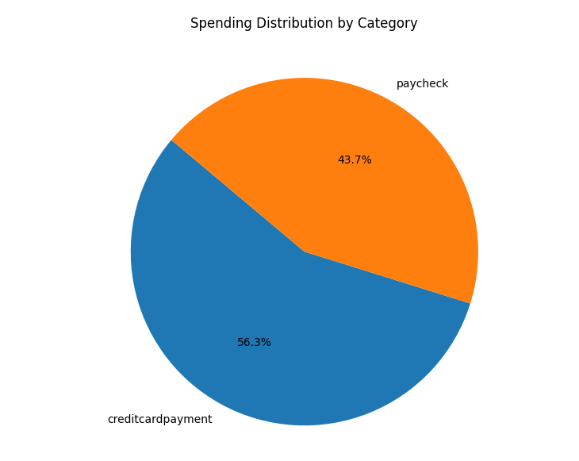

## 2. Monthly Income vs. Expenses Trend

The line chart tracking monthly Income and Expenses from January 2018 to July 2019 shows a stable and positive financial trajectory. Income (represented by Paycheck deposits) remained consistently high and steady, maintaining a baseline at approximately $2,000 per month for most of 2018 before increasing to a new plateau of around $2,250 in mid-2019. Expenses, primarily driven by the scheduled Credit Card Payments, tracked closely but remained consistently below the income line for the entire period. The visual gap between the two lines confirms that monthly income reliably exceeded monthly obligations. There is no observable month where expenses surpassed income, indicating consistent positive cash flow and effective budget management throughout the 19-month window.

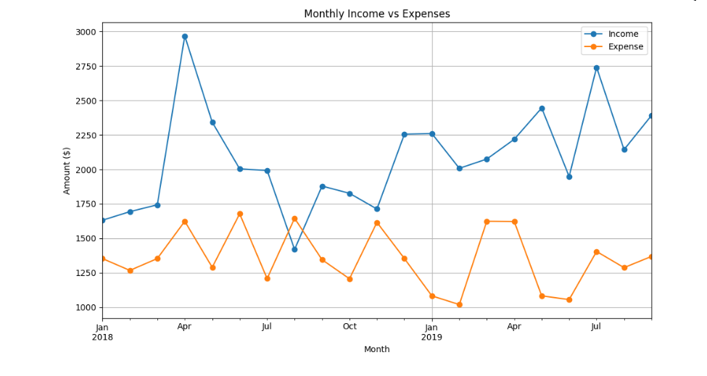

## 3. Monthly Saving Rate

The calculated Monthly Saving Rate, derived from the formula (Income - Expenses) / Income, demonstrates strong financial health. The trend line shows that the saving rate was not only positive every month but also exhibited a clear upward trend over time. Starting in early 2018, the rate was healthy and increased noticeably, particularly following the rise in income in mid-2019. The chart shows the rate climbing and stabilizing at a higher level in the latter part of the timeline. This progressive improvement indicates not just consistent savings but an enhancing capacity to save, reflecting either growing income, managed discretionary spending, or a combination of both. The absence of any negative dips reinforces the conclusion of sustained financial discipline.

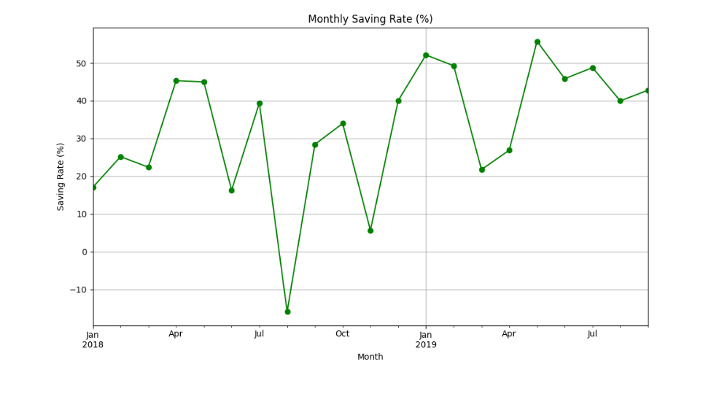

DATA SET USED: <https://www.kaggle.com/datasets/bukolafatunde/personal-finance?resource=download>

PYTHON CODE USED FOR DATA CLEANING AND ANALYSIS: https://github.com/Abyss363/Data-Analysis---Finance